**5 Best Linux Package Managers for Linux Newbies**

[Ravi Saive](https://www.tecmint.com/author/admin/)June 9, 2016 Categories [Package Managers](https://www.tecmint.com/category/package-managers/) [5 Comments](https://www.tecmint.com/linux-package-managers/#comments)

One thing a new Linux user will get to know as he/she progresses in using it is the existence of several Linux distributions and the different ways they manage packages.

Package management is very important in Linux, and knowing how to use multiple package managers can proof life saving for a power user, since downloading or installing software from repositories, plus updating, handling dependencies and uninstalling software is very vital and a critical section in Linux system Administration.

[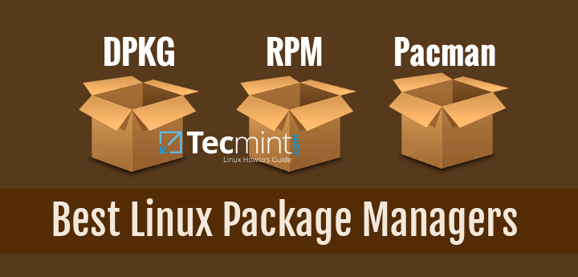](https://www.tecmint.com/wp-content/uploads/2016/06/Best-Linux-Package-Managers.png)Best Linux Package Managers

Therefore to become a Linux power user, it is significant to understand how the major Linux distributions actually handle packages and in this article, we shall take a look at some of the best package managers you can find in Linux.

Here, our main focus is on relevant information about some of the best package managers, but not how to use them, that is left to you to discover more. But I will provide meaningful links that point out usage guides and many more.

**1. DPKG – Debian Package Management System**

**Dpkg** is a base package management system for the Debian Linux family, it is used to install, remove, store and provide information about .deb packages.

It is a low-level tool and there are front-end tools that help users to obtain packages from remote repositories and/or handle complex package relations and these include:

**Don’t Miss:** [15 Practical Examples of “dpkg commands” for Debian Based Distros](https://www.tecmint.com/dpkg-command-examples/)

**APT (Advanced Packaging Tool)**

It is a very popular, free, powerful and more so, useful command line package management system that is a front end for **dpkg** package management system.

Users of **Debian** or its derivatives such as **Ubuntu** and **Linux Mint** should be familiar with this package management tool.

To understand how it actually works, you can go over these how to guides:

**Don’t Miss:** [15 Examples of How to Use New Advanced Package Tool (APT) in Ubuntu/Debian](https://www.tecmint.com/apt-advanced-package-command-examples-in-ubuntu/)

**Don’t Miss:** [25 Useful Basic Commands of APT-GET and APT-CACHE for Package Management](https://www.tecmint.com/useful-basic-commands-of-apt-get-and-apt-cache-for-package-management/)

**Aptitude Package Manager**

This is also a popular command line front-end package management tool for **Debian** Linux family, it works similar to **APT** and there have been a lot of comparisons between the two, but above all, testing out both can make you understand which one actually works better.

It was initially built for Debian and its derivatives but now its functionality stretches to **RHEL** family as well. You can refer to this guide for more understanding of APT and Aptitude:

**Don’t Miss:** [What is APT and Aptitude? and What’s real Difference Between Them?](https://www.tecmint.com/difference-between-apt-and-aptitude/)

**Synaptic Package Manager**

Synaptic is a GUI package management tool for APT based on GTK+ and it works fine for users who may not want to get their hands dirty on a command line. It implements the same features as **apt-get** command line tool.

**2. RPM (Red Hat Package Manager)**

This is the Linux Standard Base packing format and a base package management system created by **RedHat**. Being the underlying system, there several front-end package management tools that you can use with it and but we shall only look at the best and that is:

**YUM (Yellowdog Updater, Modified)**

It is an open source and popular command line package manager that works as a interface for users to RPM. You can compare it to **APT** under Debian Linux systems, it incorporates the common functionalities that APT has. You can get a clear understanding of YUM with examples from this how to guide:

**Don’t Miss:** [20 Linux YUM Commands for Package Management](https://www.tecmint.com/20-linux-yum-yellowdog-updater-modified-commands-for-package-mangement/)

**DNF – Dandified Yum**

It is also a package manager for the RPM-based distributions, introduced in **Fedora 18** and it is the next generation of version of YUM.

If you have been using **Fedora 22** onwards, you must have realized that it is the default package manager. Here are some links that will provide you more information about DNF and how to use it:

**Don’t Miss:** [DNF – The Next Generation Package Management for RPM Based Distributions](https://www.tecmint.com/dnf-next-generation-package-management-utility-for-linux/)

**Don’t Miss:** [27 ‘DNF’ Commands Examples to Manage Fedora Package Management](https://www.tecmint.com/dnf-commands-for-fedora-rpm-package-management/)

**3. Pacman Package Manager – Arch Linux**

It is a popular and powerful yet simple package manager for Arch Linux and some little known Linux distributions, it provides some of the fundamental functionalities that other common package managers provide including installing, automatic dependency resolution, upgrading, uninstalling and also downgrading software.

But most effectively, it is built to be simple for easy package management by Arch users. You can read this [Pacman overview](https://wiki.archlinux.org/index.php/Pacman) which explains into details some of its functions mentioned above.

**4. Zypper Package Manager – openSUSE**

It is a command line package manager on **OpenSUSE** Linux and makes use of the libzypp library, its common functionalities include repository access, package installation, resolution of dependencies issues and many more.

Importantly, it can also handle repository extensions such as patterns, patches, and products. New OpenSUSE user can refer to this following guide to master it.

**Don’t Miss:** [45 Zypper Commands to Master OpenSUSE Package Management](https://www.tecmint.com/zypper-commands-to-manage-suse-linux-package-management/)

**5. Portage Package Manager – Gentoo**

It is a package manager for **Gentoo**, a less popular Linux distribution as of now, but this won’t limit it as one of the best package managers in Linux.

The main aim of the Portage project is to make a simple and trouble free package management system to include functionalities such as backwards compatibility, automation plus many more.

For better understanding, try reading [Portage project](https://wiki.gentoo.org/wiki/Project:Portage) page.

**Concluding Remarks**

As I already hinted at the beginning, the main purpose of this guide was to provide Linux users a list of the best package managers but knowing how to use them can be done by following the necessary links provided and trying to test them out.

Users of the different Linux distributions will have to learn more on their own to better understand the different package managers mentioned above.

Tags [dpkg command](https://www.tecmint.com/tag/dpkg-command/), [rpm](https://www.tecmint.com/tag/rpm/), [zypper](https://www.tecmint.com/tag/zypper/) Post navigation

[How to Use Compound Expressions with Awk in Linux – Part 5](https://www.tecmint.com/combine-multiple-expressions-in-awk/)

[How to Use ‘next’ Command with Awk in Linux – Part 6](https://www.tecmint.com/use-next-command-with-awk-in-linux/)

If you liked this article, then do [subscribe to email alerts](https://newsletter.tecmint.com/subscription?f=hj6Ohm9gck3Z0PQ2BBBTh892iaCbDV3jJJa3hD8ULUlubOgnbo8aF44vt2HZfdc36g) for Linux tutorials. If you have any questions or doubts? do [ask for help in the comments](https://www.tecmint.com/linux-package-managers/#comments) section.

**If You Appreciate What We Do Here On TecMint, You Should Consider:**

TecMint is the fastest growing and most trusted community site for any kind of Linux Articles, Guides and Books on the web. Millions of people visit TecMint! to search or browse the thousands of published articles available FREELY to all.

If you like what you are reading, please consider buying us a coffee ( or 2 ) as a token of appreciation.

[](https://www.buymeacoffee.com/tecmint)

**We are thankful for your never ending support.**

**Related Posts**

[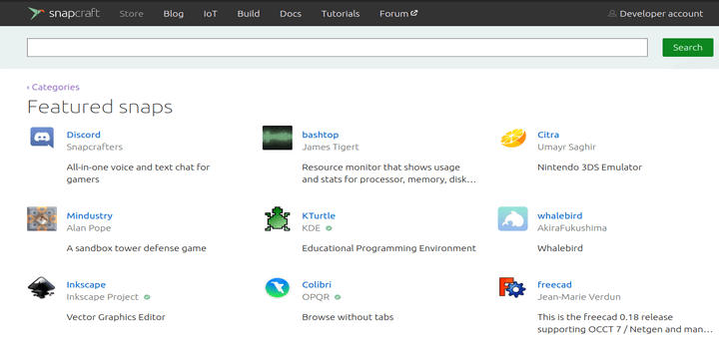](https://www.tecmint.com/best-apps-in-snap-store/)

[10 Interesting and Useful Apps I Discovered in Snap Store](https://www.tecmint.com/best-apps-in-snap-store/)

[](https://www.tecmint.com/cross-distribution-package-managers-for-linux/)

[Top 3 Open-Source Cross-Distribution Package Management Systems for Linux](https://www.tecmint.com/cross-distribution-package-managers-for-linux/)

[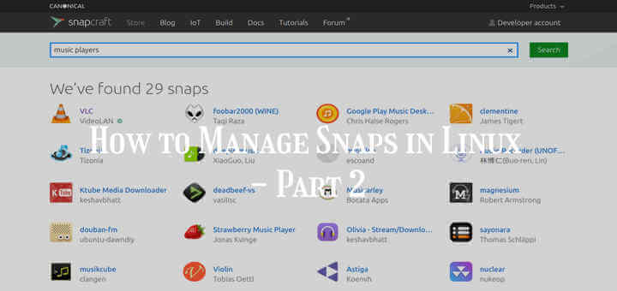](https://www.tecmint.com/manage-snaps-in-linux/)

[How to Manage Snaps in Linux – Part 2](https://www.tecmint.com/manage-snaps-in-linux/)

[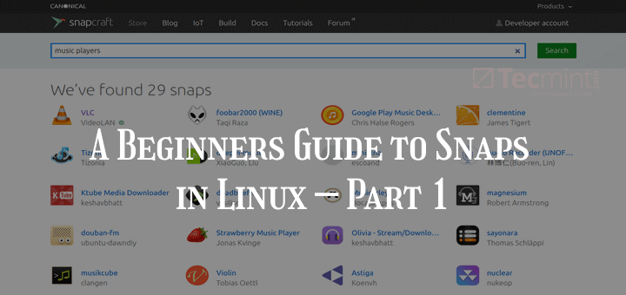](https://www.tecmint.com/install-snap-in-linux/)

[A Beginners Guide to Snaps in Linux – Part 1](https://www.tecmint.com/install-snap-in-linux/)

[](https://www.tecmint.com/linuxbrew-package-manager-for-linux/)

[Linuxbrew – The Homebrew Package Manager for Linux](https://www.tecmint.com/linuxbrew-package-manager-for-linux/)

[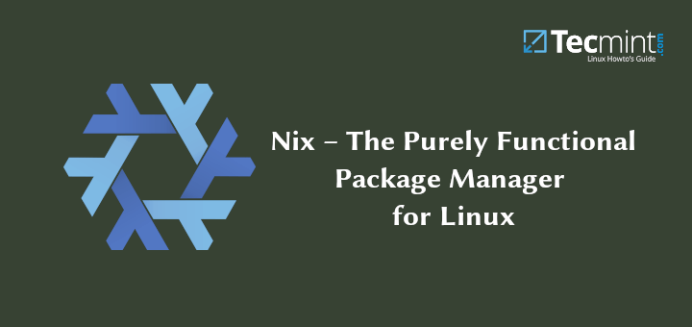](https://www.tecmint.com/nix-package-manager-for-linux/)

[Nix – The Purely Functional Package Manager for Linux](https://www.tecmint.com/nix-package-manager-for-linux/)

**5 thoughts on “5 Best Linux Package Managers for Linux Newbies”**

1. 

*farzad*

[March 30, 2021 at 6:10 pm](https://www.tecmint.com/linux-package-managers/#comment-1465337)

I agree with @dragonmouth Newbies are very scary about terminal and command line (including myself at the beginning). Imagine users used to a perfect graphical interface and switch to one window and just one line that says [host@user]~$: that is scary right? that means newbies want a gui! want a graphical interface, not a command-line tool.

I wish Linux writers write that way “Linux is easy to learn even for those who not like it, and not like terminal! ” In this way, I am sure newbies won’t switch back to their previous OS…

sorry for the bad English. It’s not my native language.

[Reply](https://www.tecmint.com/linux-package-managers/?replytocom=1465337#respond)

1. 

*Jalal*

[December 16, 2020 at 12:04 pm](https://www.tecmint.com/linux-package-managers/#comment-1401740)

Hi,

Thank you so much for the great topic.

[Reply](https://www.tecmint.com/linux-package-managers/?replytocom=1401740#respond)

1. 

*dragonmouth*

[November 14, 2020 at 8:28 pm](https://www.tecmint.com/linux-package-managers/#comment-1389310)

“5 Best Linux Package Manager